 | Beverly Hills Unified School District  CalServe Service-Learning Project  Project Information Log | 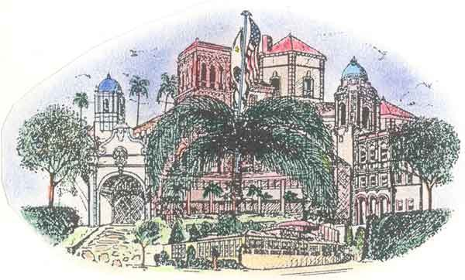

Teacher: School:

Grade Level

Date(s):

Curriculum Area(s):

Academic Content Standards:

Community Need:

Briefly describe the Service-Learning activity:

Did you work with a community agency (which)?

Phone No.:

Did you have a guest speaker or liaison (who)?

Reflections (yours, and activity done with students):

I hereby grant permission for the publication of my summary in the CalServe Annual Report and similar documents.

Teacher Signature: Date:

